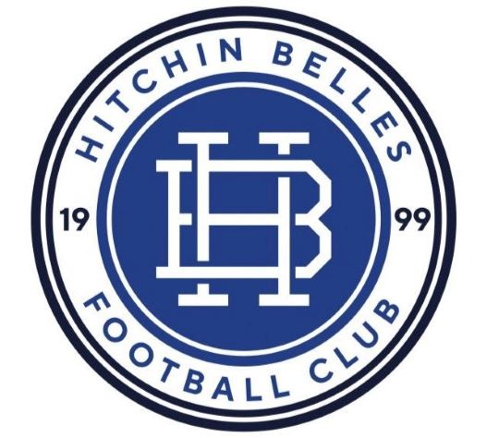
Hitchin Belles FC
The Home of Female Football in Hitchin

Volunteering Policy

- Introduction
Hitchin Belles Football Club is one of the leading and largest female only football clubs in the Country with over 250 girls, predominantly from the North Herts area. We also offer Futsal to all as well as many other recreational activities. Our club is run solely by volunteers.

The objective of the Volunteering Policy is to
- Ensure everyone in the club understands why volunteers are important and their value.
- A reference document for all volunteers
- To ensure best practice is followed when involving volunteers

- Core Values
- Our volunteers are treated fairly, supported and giving the opportunity to develop
- Volunteers benefit from their involvement, socially and educationally by learning new skills
- Volunteering opens many doors! Volunteers become part of a larger network and take part in local and national events through the Arsenal Sister Club Programme and The FA.
- Volunteers can be rewarded and recognised through regional and national Grassroots Awards as well as the club annual awards.

- Recruitment, Training and Development
- Volunteering is open to everyone
- You do not need to be a football expert!
- There is a process to follow before you can start which is simple and funded by the club, this includes
Step 1 – Meeting with our Child Welfare Team to arrange a Criminal Records Check (£10-£60) (CRC/DBS)
Step 2 – Identify a suitable date to attend a Safeguarding Children Workshop with Hertfordshire Football Association (£30)
Step 3 – You can shadow another coach/manager/committee member before starting. As a volunteer you control the pace you learn
- Volunteers receive an information pack
- Volunteers involved in managing/coaching a team will be funded to attend their FA coaching qualifications and join the licence coaches club to receive coaching resources
- Volunteers receive kit and equipment and can claim expenses

The following will be reimbursed by the club through expenses claim, DBS application, Safeguarding Course, FA First Aid Course, FA Level 1 Course.

- Why Volunteer with Hitchin Belles FC?
- Volunteering, you become one of the ‘Belles’ family
- You build your social network
- It is rewarding
- You provide opportunities for more girls to get involved in football
- There is a real sense of purpose
- Help shape the female game
- You volunteer as much as you can, it’s under your control
- Many volunteers take on more than one role but with more volunteers we can help distribute roles equally
- You will not be alone on your volunteering journey

